**Drainage Cleaning Robot**

**Abstract:**

The proposed concept in this paper is to replace the manual work in drainage cleaning by a semi automated system. Impurities in drainage water can be only like empty bottles, polythene bags, papers …etc. These impurities present in drainage water can cause blockage in the drainage system. The drainage system can be cleaned time to time manually or such a system can be designed that will semi automatically throw out wastages and will keep the water clean. This project is designed to keep clean the drainage system and helps the smooth working of the system. This project semi automatically cleans the water in the drainage system each time any wastage appears and this form an efficient and easy way of cleaning the drainage system and preventing the blockage. Our proposed project uses special pulley system, D.C motor, Robo gripper, power supply (DC) and drainage waste storage box to work as automatic drainage cleaning system. The device is place across an open drain floating waste like bottles, plastic cans, covers…..etc. is lifted by Robo gripper which are connected to the pulley. The pulley revolves with the help of D.C motor. When motor runs the pulley starts to move downward and the waste materials are lifted up by the Gripper and stored in storage or collecting bin. Once the collecting bin is full, the waste materials are automatically dumped from the bin to the side of drain. This all are monitored controlled and run by using a handy DPDT Switch System that can run by manual control (semi manually).

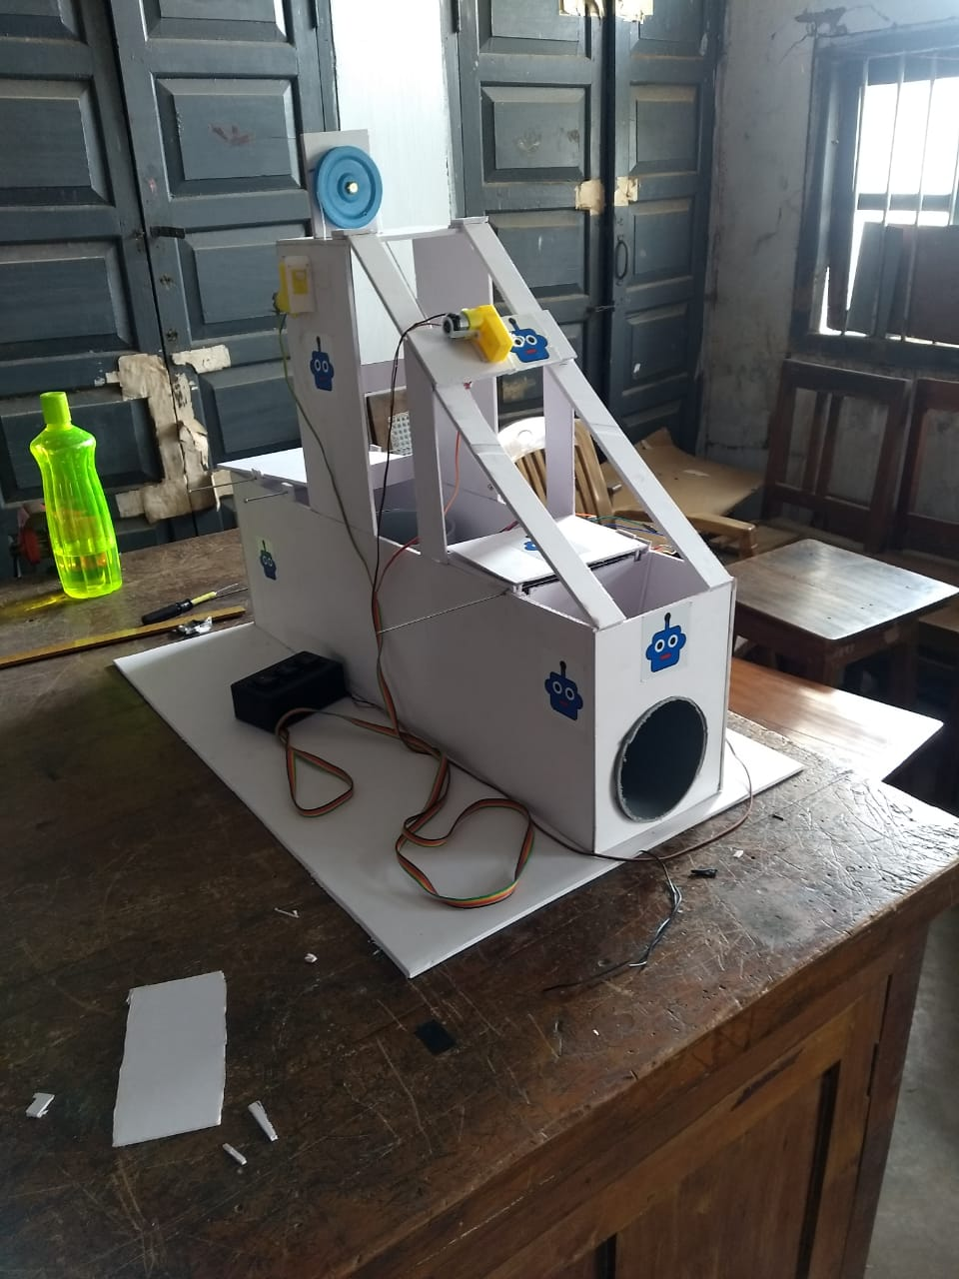

INTRODUCTION

In today’s era automation plays a very important role in all industrial applications for the proper disposal of sewage from industries and household is still a challenging task. In India drainage systems are usually open which leads to disposal of solid waste and that causes blockage. Drains are used for the adequate disposal of waste and unfortunately sometimes there may be a threat to human life during the cleaning of blockage in the drains or it can cause serious health issues because of the pertaining problems like malaria, dengue, etc. In order to overcome this problem as well as to save human life we implement a design “Automatic Drainage Cleaning System”. We designed our project in order to use it in an efficient way to control the disposal of waste along with regular filtration of drains, removal of solid waste in order to avoid blockage in drains to promote continuous flow of drainage water which ultimately reduces the threat to human life.

**BLOCK DIAGRAM:**

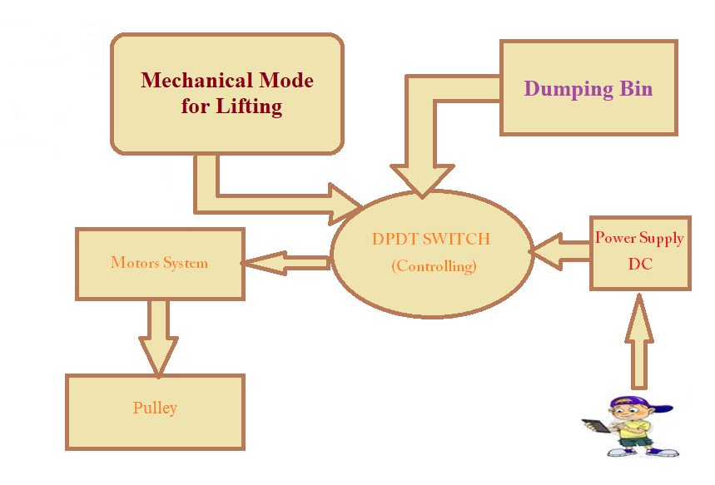

**DC Motor:-**

A DC motor is any of a class of rotary electrical machines that converts direct current electrical energy into mechanical energy. The most common types rely on the forces produced by magnetic fields. Nearly all types of DC motors have some internal mechanism, either electromechanical or electronic, to periodically change the direction of current flow in part of the motor.

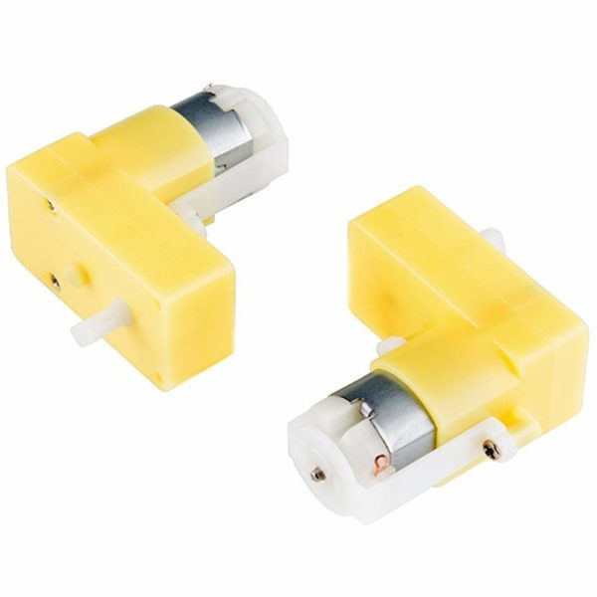

**Mechanical setup**

The mechanical setup is the final fabrication of the system using mechanical components that includes outer casing as shown in Fig. Once the design meets the requirements, the real time setup is fabricated. The base of gadget is of dimension 100cm*60cm*30cm, with wheel dimension helps to cover various drainage system. The lifting part of the setup consist of pulley and robo gripper system that takes out the solid waste material from the drain the basis structure of this pulley and robo gripper are shown in figure below.

**Wheels:-**

A circular object that revolves on an axle and is fixed below a vehicle or other object to enable it to move easily over the ground.

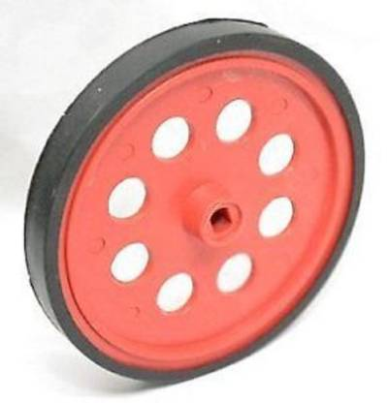

**pulley system**

A **pulley system** makes it easier to lift an object than lifting the dead weight by hand. A single **pulley** essentially changes the direction of the pull or force applied. When a person uses two or more **pulleys** in a **system**, then the **system** also multiplies the force applied besides changing its direction.

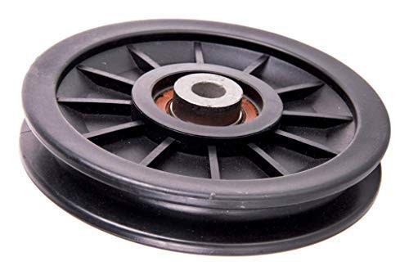

**robot gripper:**

A gripper is a device which enables the holding of an object to be manipulated. The easier way to describe a gripper is to think of the human hand. Just like a hand, a gripper enables holding, tightening, handling and releasing of an object. A gripper is just one component of an automated system.

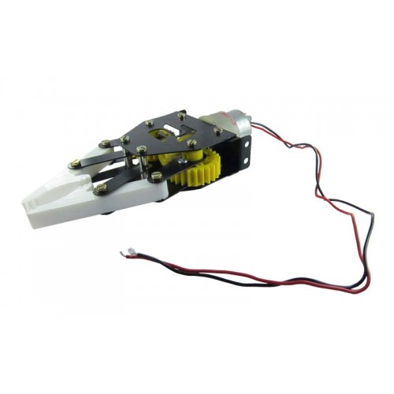

**WORKING:**

Floating waste like bottles, plastic cans, covers etc., are lifted by the robo gripper which is connected to the pulley system. The whole mechanism is basically above the drain only lifting part goes inside the drain .This again reduces the wear and tear. The pulley revolves with the sprocket wheel which is driven by a motor. When the motor runs, the pulley starts to circulate and it makes the gripper to move downwards. Floating waste like bottles, plastic cans, covers…..etc. is lifted by Gripper which are connected to the pulley. The wastage material are lifted by the gripper and stored in a collector bin. Once the collecting bin is full, the waste materials are removed from the bin automatically.

This proposed system is similar to a remote operated car using switch. The system/robot fully runs across the drainage semi automatically. Our proposed project uses special gripper system, D.C motor, D.C power supply, bearing, shaft, carrier, pulley, and drainage waste storage box(bin), DPDT Switch to work as semi automatic drainage cleaning system/robot.

1. The gadget is place over the drain.

2. This anchor is appended to equip driven by motor. Motor is begin

Pulley is begun to circle.

3. Making gripper hold the waste and lift up squandered material put

away in tank.

4. Motor can use to rotate pulley drive system and robo gripper.

5. This system can operate on DC power supply.

6. And the whole system is controlled manually through the DPDT

switch.

**RESULT AND CONCLUSION**

Our literature review highlights the ongoing advancement in the drainage cleaning system. Many specific empirical studies have been carried out and categories such as semi automatic drainage cleaning system and its automation have been studied to a great depth. We focus more on making the system simpler for the drainage cleaning.

In the treatment system of drainage Waste water control by the motor, pulley system, robo gripper and the collecting bin to achieve semi-automatic control of sewage waste water treatment.

The system can move in the drain to collect the floating waste so as to reduce human labor.

The cleaner functioned move effectively during the heavier rains which had more volume of running water with

garbage and high velocity.

**FUTURE SCOPE**

For Future project this is going to be IOT Based and the mosquito repellent technology will be employed using 555 timer IC ,Sonar Sensors are also used to avoid the obstacles in the path of gadget and Display module will provide the necessary operation. And that will be fully automatic.

**REFERENCES**

[1] Harshal S Shinde , Asst. Professor, Shatabdi institute of engineering & research, Nasik, Nadia, volume 2, issue 2,

February 2017 ISSN : 2456-0006 .

[2] Prakash.S, Rajkumar.P, Sakthivel.C, Sugumar.G, park college of engineering and technology ,Coimbatore.

[3] Ganesh, Vinod VRampur, Assistant professor, Mechanical department, Pesitm, Shimoga, Karnataka, India, Volume:

05 issue: 07 | jul-2016, eISSN: 2319-1163 | pISSN: 2321-7308.

[4] Mragank Sharma, Shahbaz Siddiqui, Archit Pawan Srivastava, Shiwam Kumar Tiwari department of mechanical and

automation engineering amity university, lucknow, india, 2017 11318 volume 7 issue no.5.

[5] https://en.wikipedia.org